Lab Report 1

Name: Snigdha Stp

Roll no.: 2023102036

Group no. : 06

Experiment 1:

Familiarisation with Digital Test Kit and Binary Logic levels.

Objective:

1. Getting familiar with the schematic and the usage of the breadboard.

2. Implementation of NOT Gate.

Electronic components required:

➢ Digital Test Kit:

• Slide switch

• Power Supply

• Red LED

• Resistor

• Breadboard

➢ Hex Inverter

➢ Connecting Wire

The Reference circuit:

Circuit diagram:

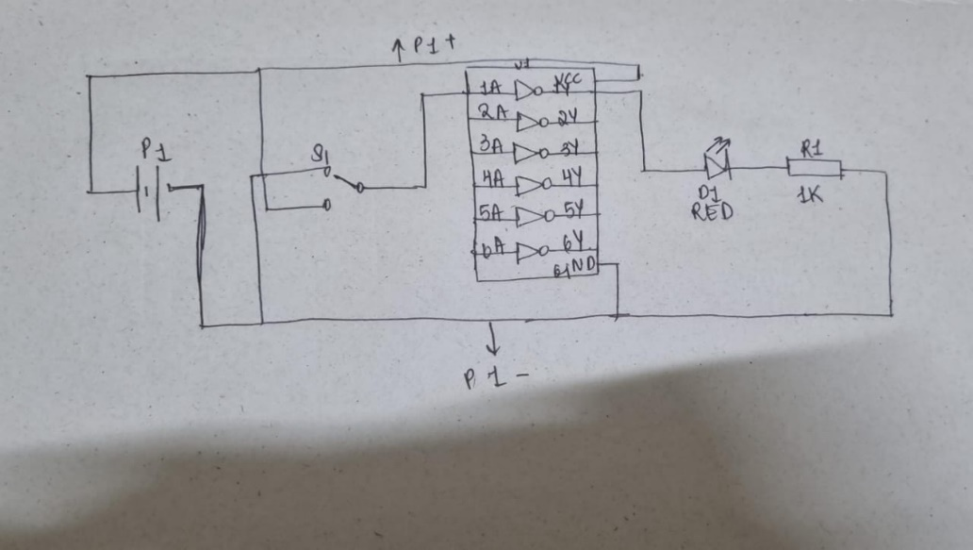

Tinkercad Diagram:

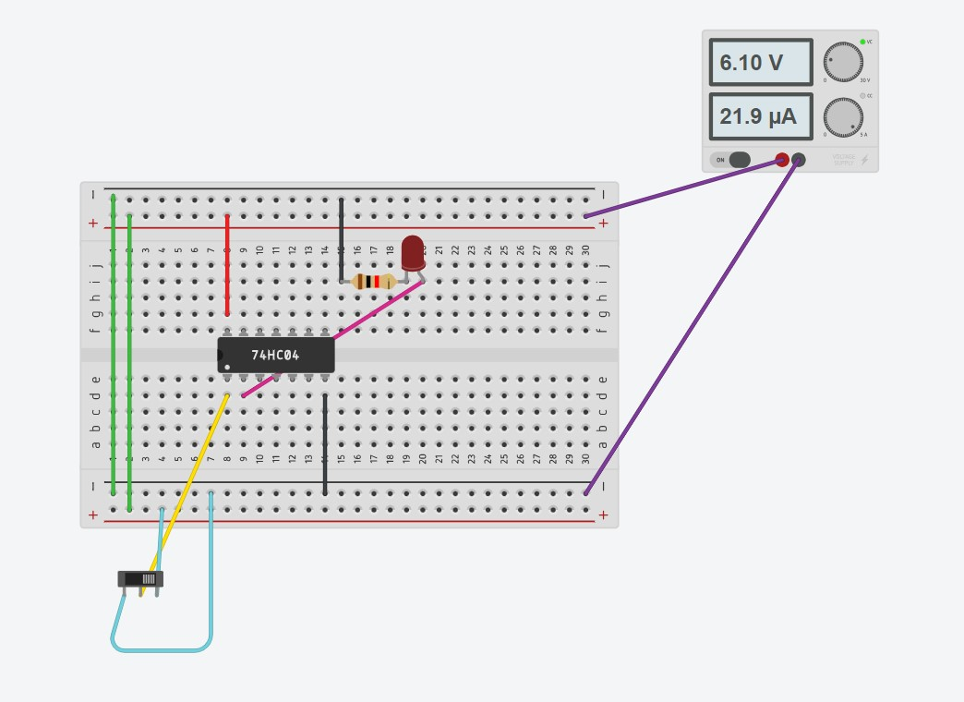

DSM Lab Circuits:

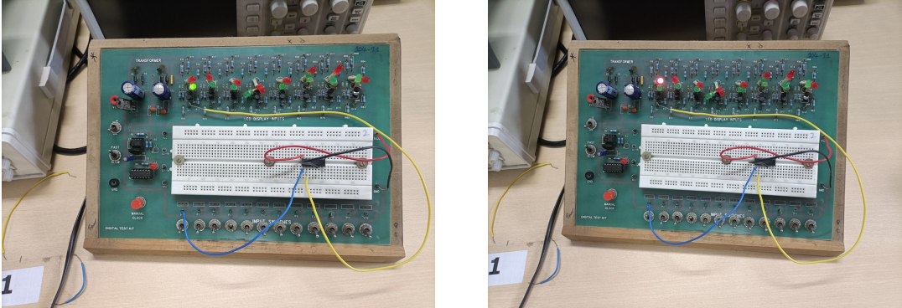

Procedure:

1. The Clock control switch is put in the FAST position and the VCC supply is switched on. We noted that the CLK-R LED starts glowing. We used a digital Multimeter (in the DC VOLTAGE mode) and noted a voltage between the VCC and GND pins.

2. Verify the working of all the Input Pins IP1-IP12 by measuring the voltages at these pins for both positions of the Input Switches. Verify the working of all the LED displays by applying an input from one of the Input Pins to DP1-DP8 and observing the LEDs as the Input is switched.

4. When we use 7404 IC and connect it to the breadboard, the circuit is setup by following the steps :

* the VCC and Gnd pins of the IC are connected to the VCC and Gnd lines on the top and the bottom of the breadboard, using RED and BLACK wires respectively.
* the input pin of any one gate in the IC is connected to one of the IP1-IP12 input switches, and the corresponding output pin of the IC to one of the DP1-DP8 display points provided in the Test Kit.

Observation:

When we switch on the circuit and the IP1 Input Switch respectively, we observe that the green LED of DP1 glows and when we turn the IP1 Input switch to off, we observe that the red LED of DP1 glows.

Conclusion:

The Green LED is meant to glow when the input signal is switched off. As per our observation, it glows when IP1 input switch is on. Conversely, the Red LED is meant to glow when the input signal is switched on. As per our observation, it glows when IP1 input switch is off. Thus we can conclude that the Hex Inverter is a NOT Gate which simply inverts the input logic for the output.

Link to Tinkercad:

<https://www.tinkercad.com/things/0U03uAoPFzs-grand-waasa-lahdi/editel?sharecode=8Pk2BWQSWgDoFbNndvg3DcnvFBvfD8OstXdg1ZZUlEE>

Experiment 2:

Familiarisation with Arduino IDE and microcontroller

Objective:

1. Implementation of NOT Gate.

2. Writing and compiling C Code for ATMega328P in Arduino ISP.

3. Dumping this file into the microcontroller, running the program and observing the output

Electronic Components required:

➢ Digital Test Kit:

• Power Supply

• Slideswitch

• Red LED

• Resistor

• Breadboard

➢ Hex Inverter

➢ Connecting Wires

➢ Arduino UNO

➢ Laptop with Arduino IDE

The Reference Circuit:

Circuit diagram:

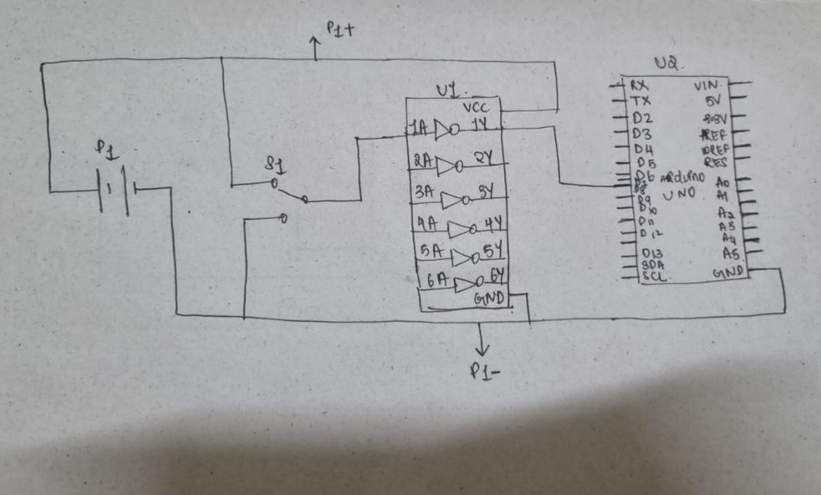

Tinkercad Diagram:

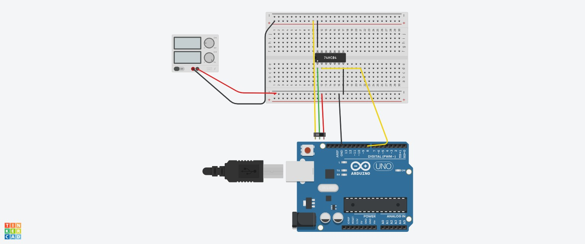

DSM lab circuits :

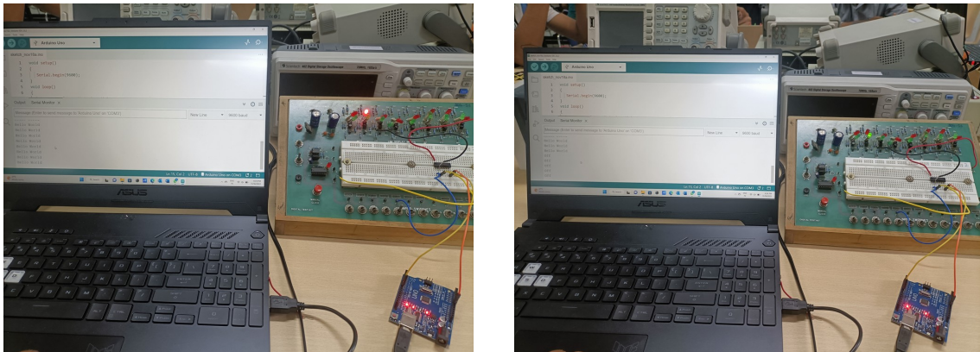

Procedure:

1. We connect 7404 IC (Hex Inverter) to the breadboard.
2. We connect the VCC supply and Gnd of the test kit to the top/bottom (+ and – respectively) of the breadboard. We connect the VCC and Gnd pins of the IC to the VCC and Gnd lines on the top and the bottom of the breadboard, using RED and BLACK wires respectively.
3. We connect the input pin of any one gate in the IC to the IP1 input switch, and the corresponding output pin of the IC to Digital pin 8 of the Arduino UNO.
4. We connect the GND pin of the Arduino to the GND pin of the IC.
5. Now we run the following code by uploading it from the IDE to the Arduino. We print “Hello World” when the output of IC into the Digital Pin of Arduino is not 0, and print “Off when the output is 0.

Arduino IDE Code:

void setup() { Serial.begin(9600); }

void loop() {

int sensorValue = digitalRead(8);

if (sensorValue)

{

Serial.print("Hello World \n");

}

else{ Serial.print("Off \n");

}

delay(1000);

}

Observation:

When we switch on the circuit and the IP1 Input Switch respectively, we observe that the serial monitor displays “Off” and when we turn the IP1 Input switch to off, we observe that “Hello World”.

Conclusion:

As per our observation, serial monitor displays “Off” when IP1 input switch is on. Conversely, it displays “Hello World” when IP1 input switch is off. Thus we conclude that the Hex Inverter is a NOT Gate which simply inverts the input logic for the output.

Link to the TinkerCad Simulation:

<https://www.tinkercad.com/things/elIGhmlvcSZ-daring-sango/editel?sharecode=ERHVZCQtF4PIMrYB86QAhckBZ-JvcTnkF-ukaxzCxBM>